R - ASSIGNMENT

**1. Create a graph with 2 vectors and include 10 points each.**

**Ans:** plot(c(1,2,3,4,5,6,7,8,9,10),c(1,2,3,4,5,6,7,8,9,10))

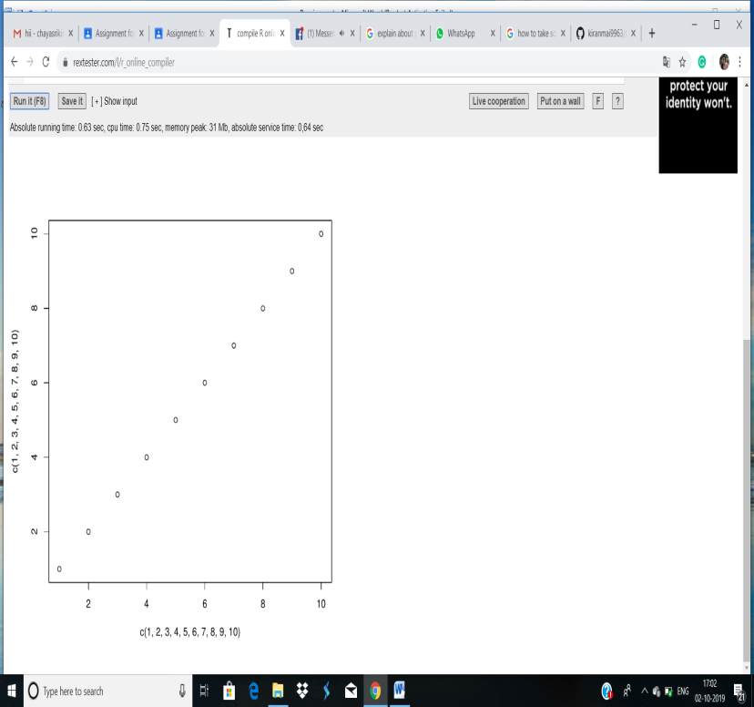  


**2. Explain about probability distribution and execute normal distribution in r.**

**Ans:** Probability Distribution: A probability distribution describes how the values of a random variable is distributed.

ex:The collection of all possible outcomes of a sequence of coin tosssing is known to follow the binomial distribution.where as the means of sufficiently large samples of data population are known to resemble the normal distribution.

**Normal Distribution**: The normal distribution is defined by the following probability density function ,where μ is the population mean and σ2 is the variance.

**f(x)=1/(σ√2π )e^-(x-μ)2/2σ2**

μ=0 and σ=1 is called standard normal distribution and is denoted as N(0,1).

It can be graphed as follows:

R has four in built functions to generate normal distribution. They are described below.

**dnorm(x, mean, sd)**

**pnorm(x, mean, sd)**

**qnorm(p, mean, sd)**

**rnorm(n, mean, sd)**

Following is the description of the parameters used in above functions −

x is a vector of numbers.

p is a vector of probabilities.

n is number of observations(sample size).

mean is the mean value of the sample data. It's default value is zero.

sd is the standard deviation. It's default value is 1.

**dnorm():**

This function gives height of the probability distribution at each point for a given mean and standard deviation.

Ex:

x <- seq(-10, 10, by = 0.1)# Create a sequence of numbers between -10 and 10 incrementing by 0.1.

y <- dnorm(x, mean = 2.5, sd = 0.5)# Choose the mean as 2.5 and standard deviation as 0.5.

plot(x,y)

**GRAPH:**

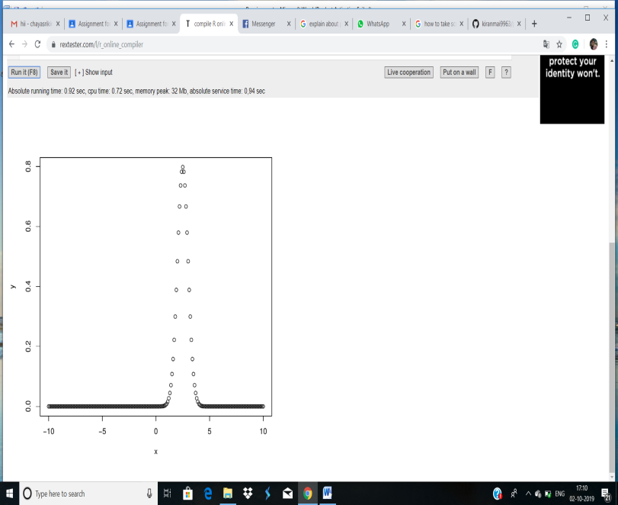  
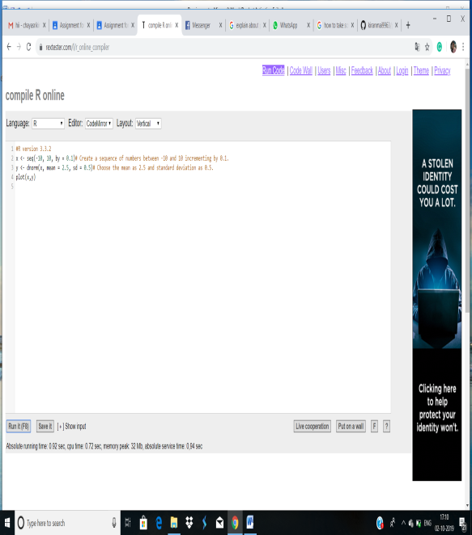

**pnorm():**

This function gives the probability of a normally distributed random number to be less that the value of a given number. It is also called "Cumulative Distribution Function".

x <- seq(-10,10,by = .2)# Choose the mean as 2.5 and standard deviation as 2.

y <- pnorm(x, mean = 2.5, sd = 2)

plot(x,y)

**GRAPH:**

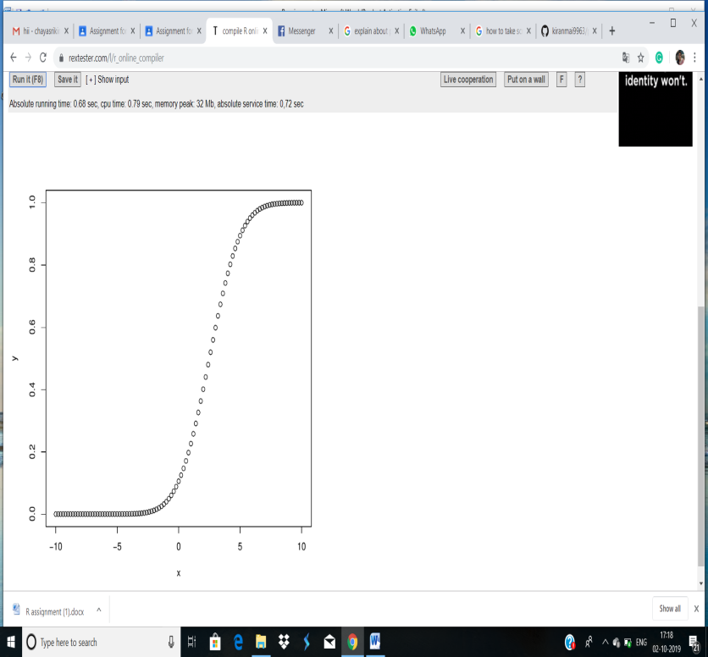  
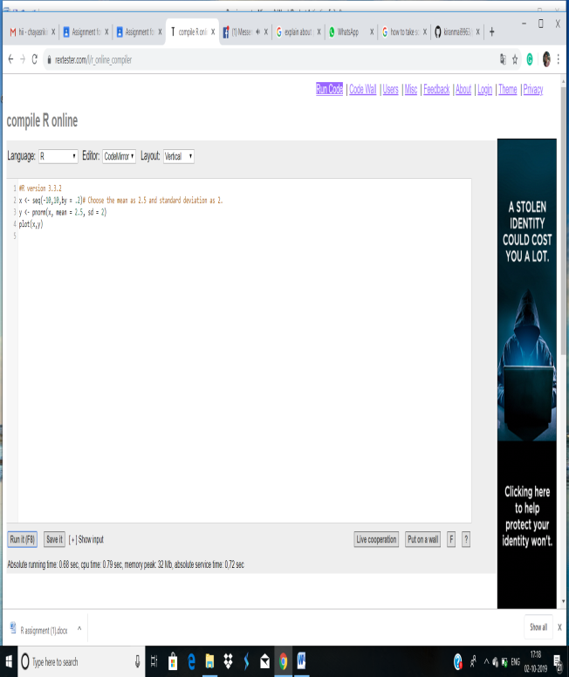

**qnorm():**

This function takes the probability value and gives a number whose cumulative value matches the probability value.

# Create a sequence of probability values incrementing by 0.02.

x <- seq(0, 1, by = 0.02)

# Choose the mean as 2 and standard deviation as 3.

y <- qnorm(x, mean = 2, sd = 1)

# Plot the graph.

plot(x,y)

**GRAPH:**

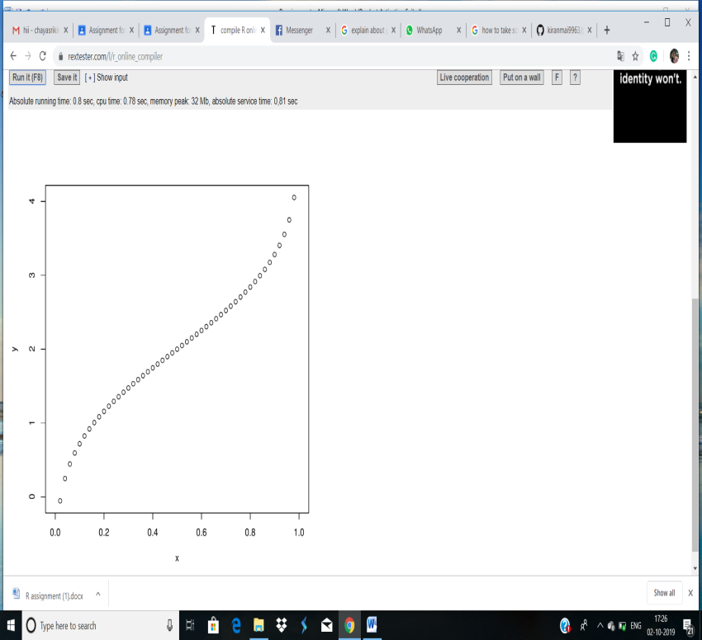  
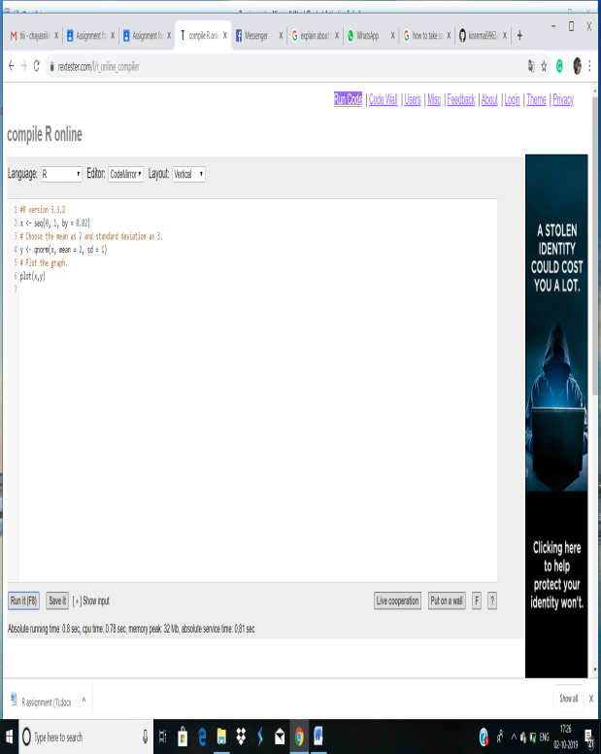

**rnorm():**

This function is used to generate random numbers whose distribution is normal. It takes the sample size as input and generates that many random numbers. We draw a histogram to show the distribution of the generated numbers.

# Create a sample of 50 numbers which are normally distributed.

y <- rnorm(50)

# Plot the histogram

hist(y, main = "Normal DIstribution")

**GRAPH:**

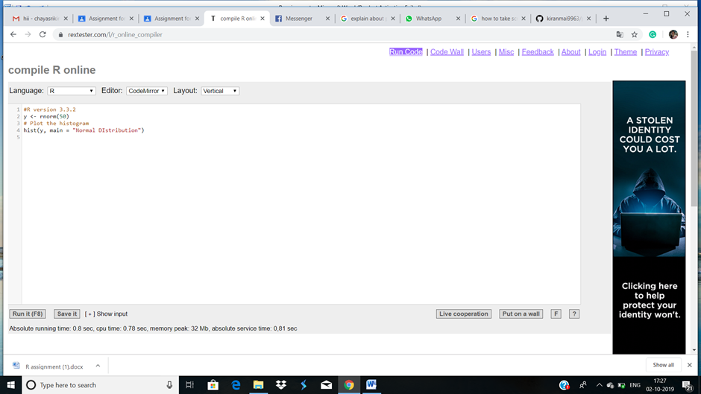

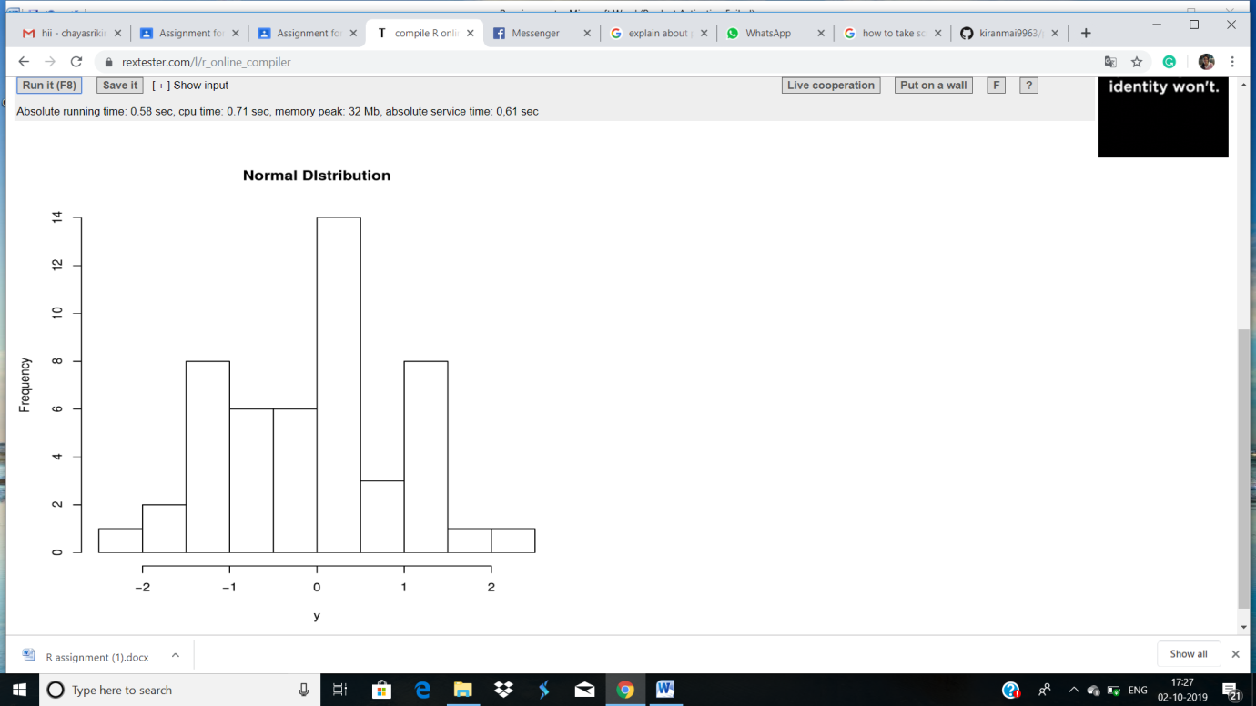

**3. Execute binomial distribution and create histograms with sizes of 1 to 10 and prob 0.1 to 0.9**

**each with n value 10.**

**Ans:** R has four in-built functions to generate binomial distribution. They are described below.

dbinom(x, size, prob)

pbinom(x, size, prob)

qbinom(p, size, prob)

rbinom(n, size, prob)

Following is the description of the parameters used −

x is a vector of numbers.

p is a vector of probabilities.

n is number of observations.

size is the number of trials.

prob is the probability of success of each trial.

**dbinom():**

This function gives the probability density distribution at each point.

Create a sample of 50 numbers which are incremented by 1.

x <- seq(0,50,by = 1)

# Create the binomial distribution.

y <- dbinom(x,50,0.5)

# Plot the graph for this sample.

plot(x,y)

**GRAPH:**

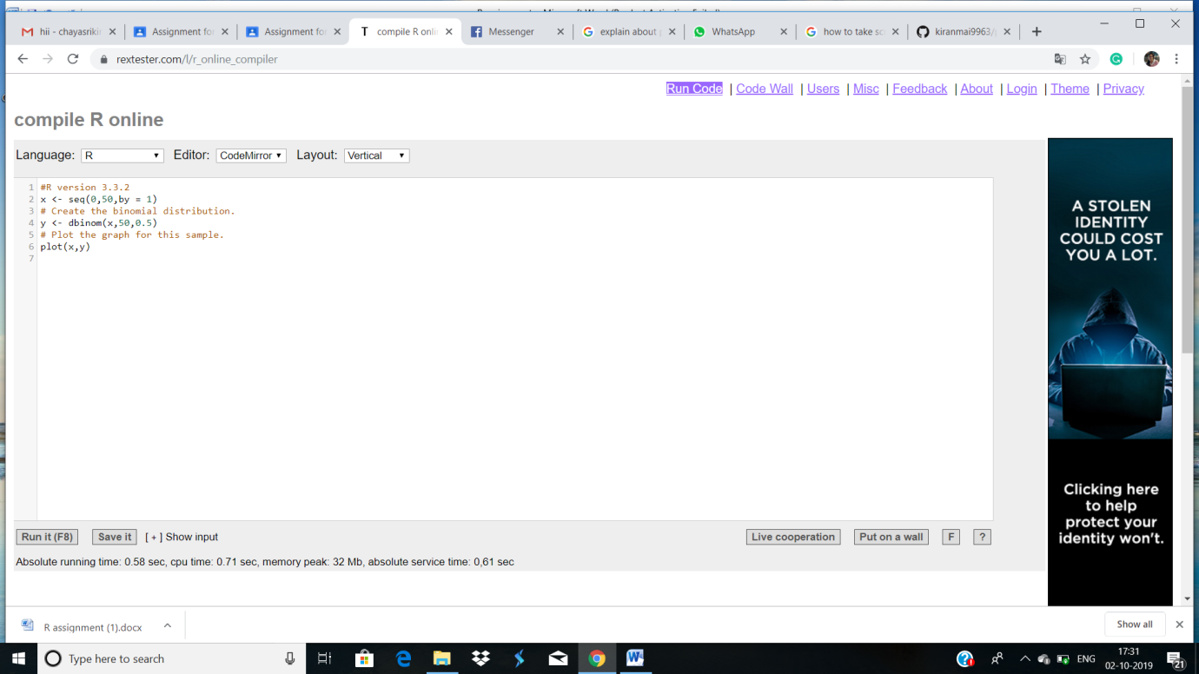

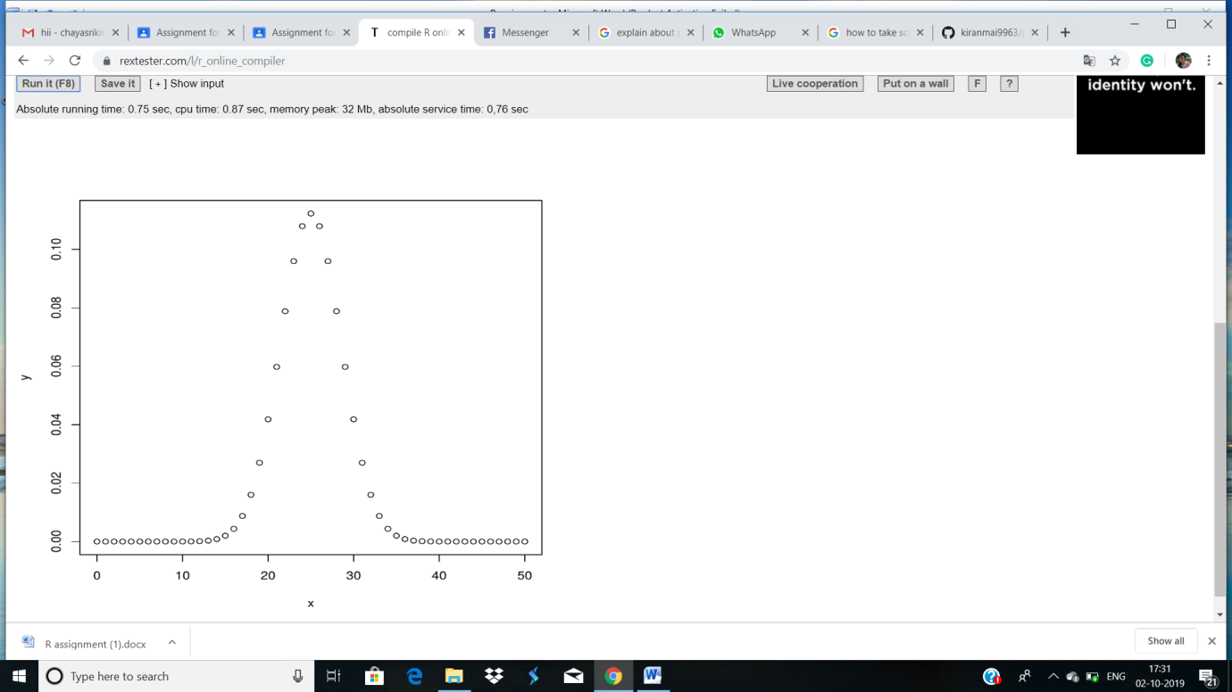

**pbinom():**

This function gives the cumulative probability of an event. It is a single value representing the probability.

# Probability of getting 26 or less heads from a 51 tosses of a coin.

x <- pbinom(26,51,0.5)

print(x)

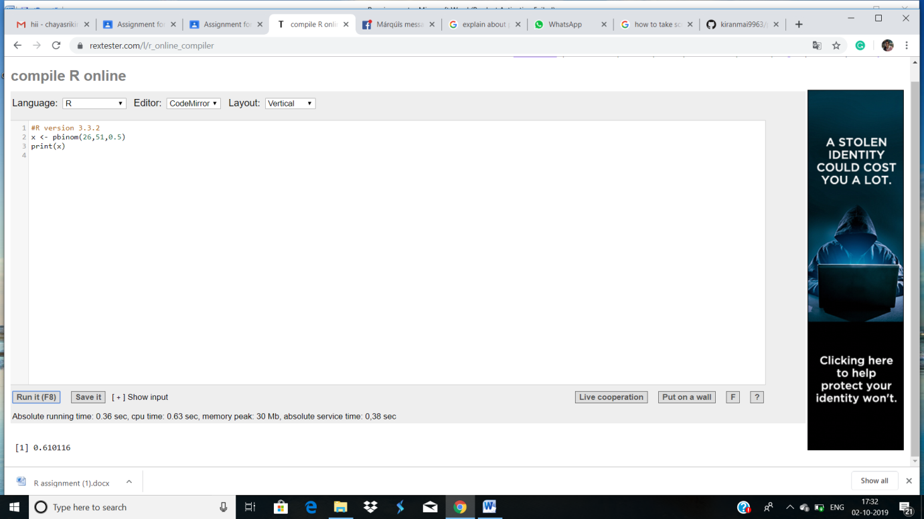

**qbinom():**

This function takes the probability value and gives a number whose cumulative value matches the probability value.

# How many heads will have a probability of 0.25 will come out when a coin

# is tossed 51 times.

x <- qbinom(0.25,51,1/2)

print(x)

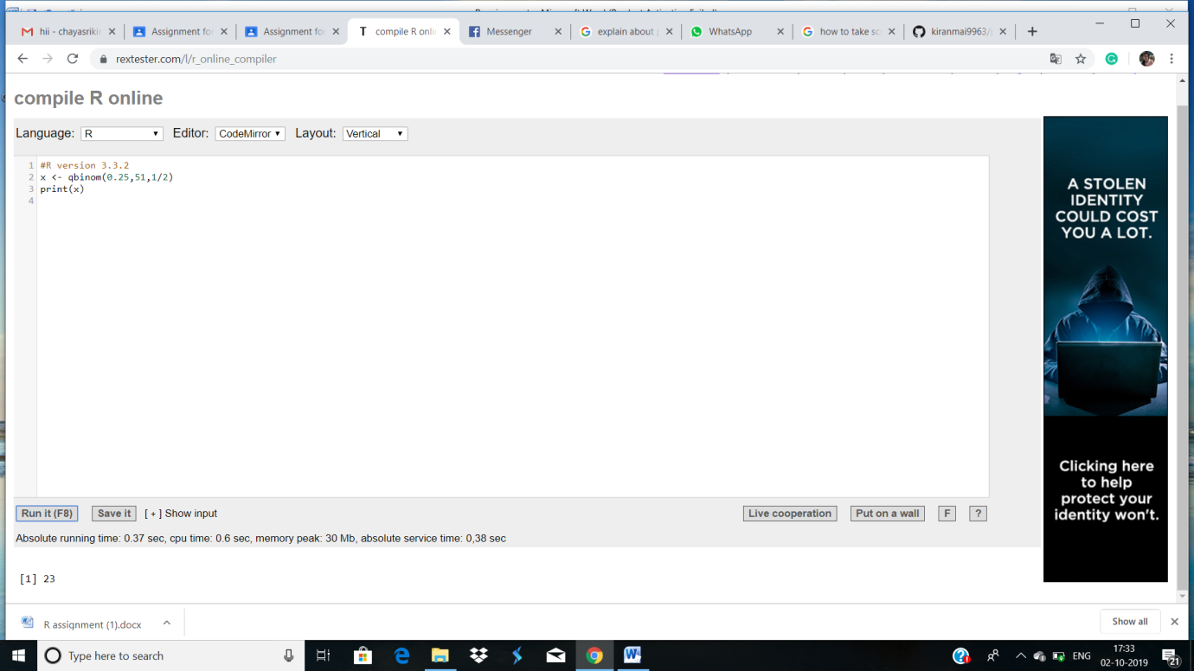

**rbinom():**

This function generates required number of random values of given probability from a given sample.

EX:

# Find 8 random values from a sample of 150 with probability of 0.4.

x <- rbinom(8,150,.4)

print(x)

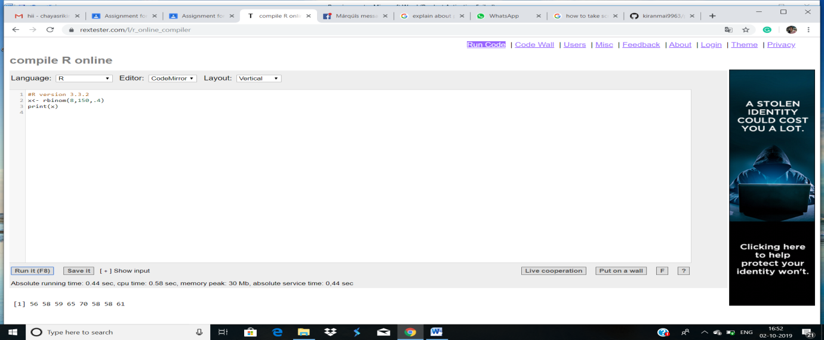

**Histogram:**

>x=c(1,2,3,4,5,6,7,8,9,10)

>hist(x,prob=0.9,n=1)

**Graph:(output)**

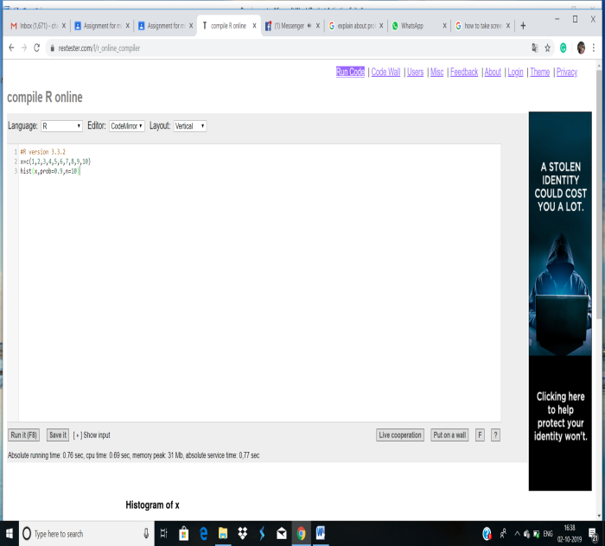  
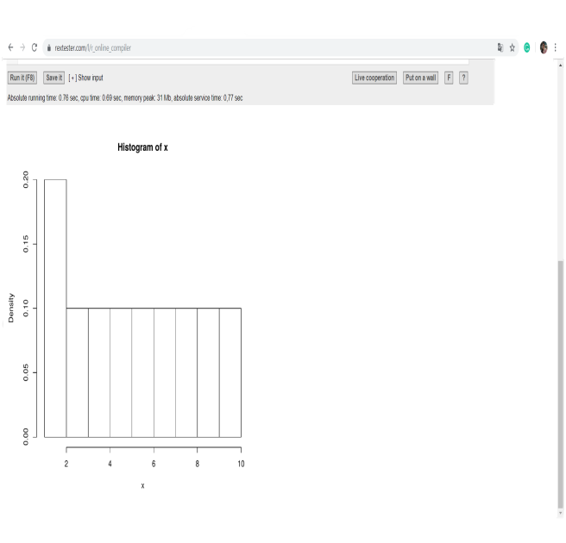

**SUBMITTED BY:**

**18HP1A1205**

**SUBMITTED TO:  
T.V.SAIRAM SIR(SRP)**